

QUAID-I-AZAM UNIVERSITY
ISLAMABAD
Mobile App Development
LAB REPORT
Name: Rafay Sultan
Reg No: 04072312037
Semester: 08
TASK 01:

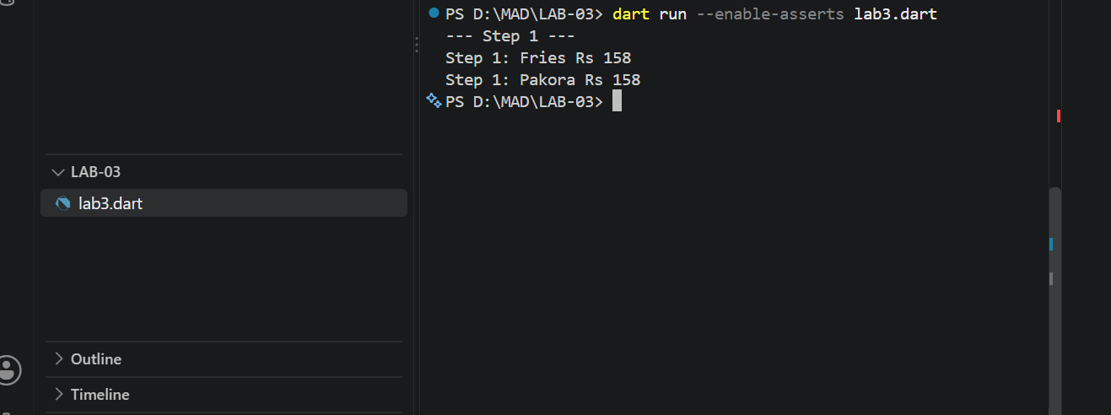

TASK 02:

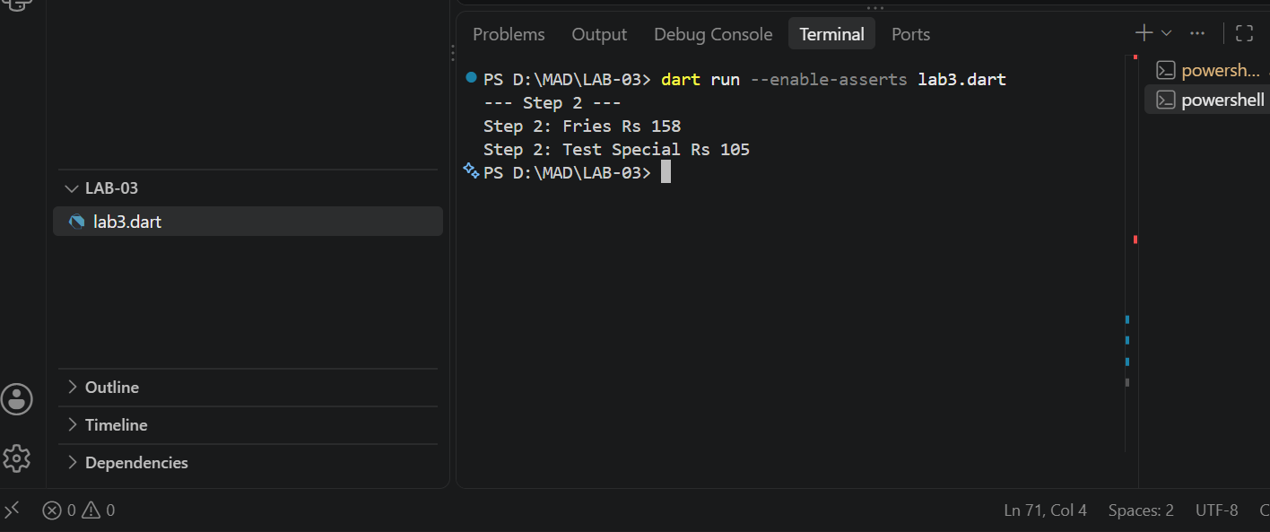

TASK 03:
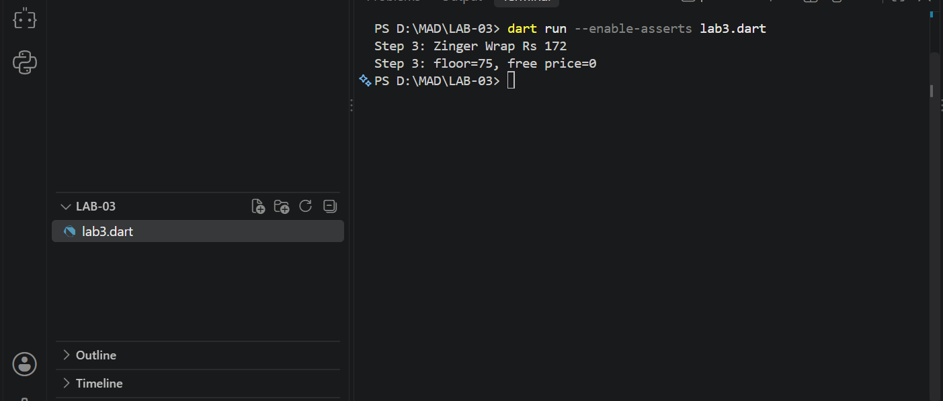

TASK 04:
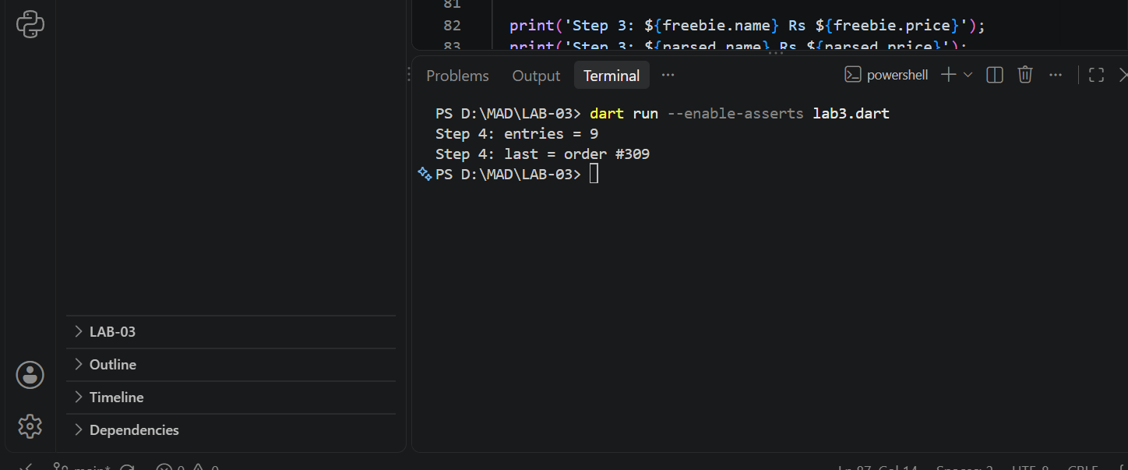
Task 05:
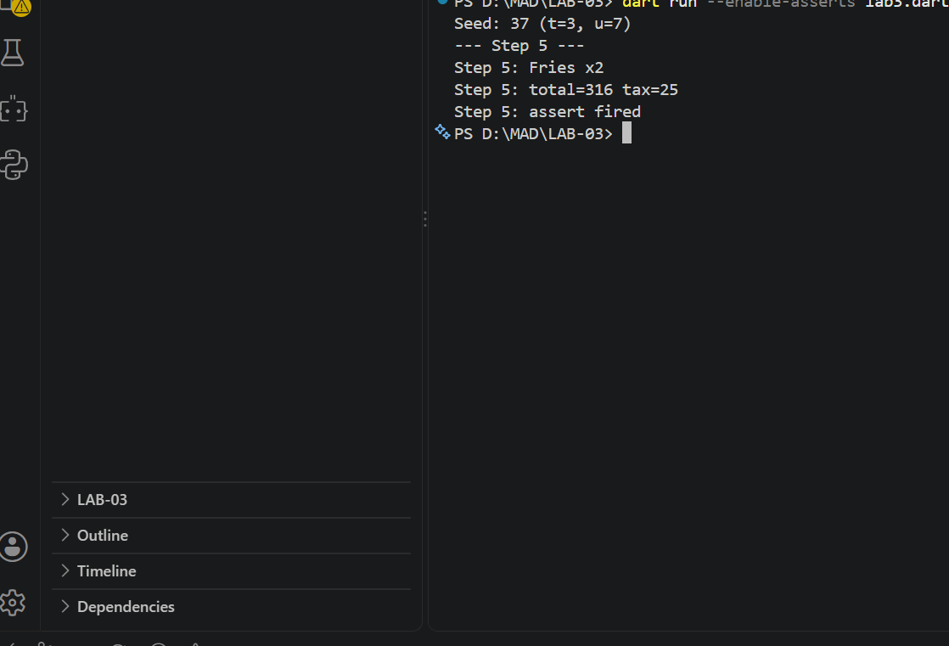

Task 06:
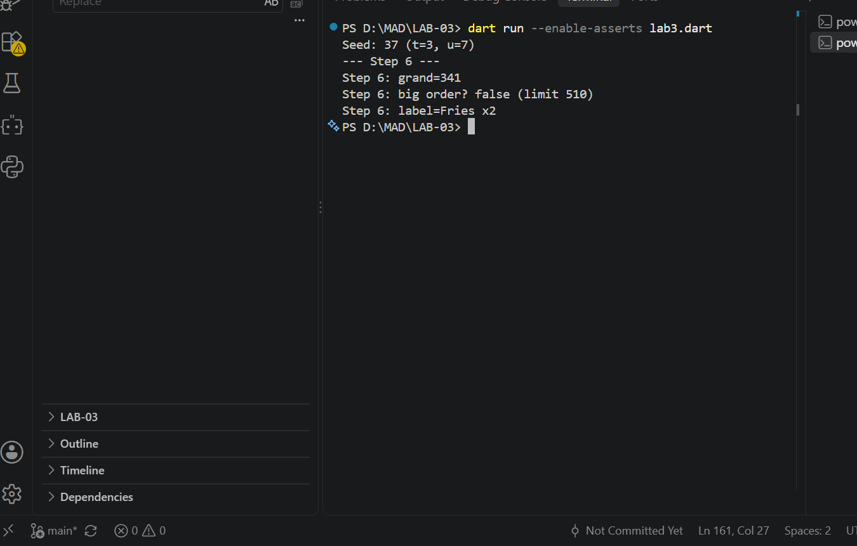
Task 07:
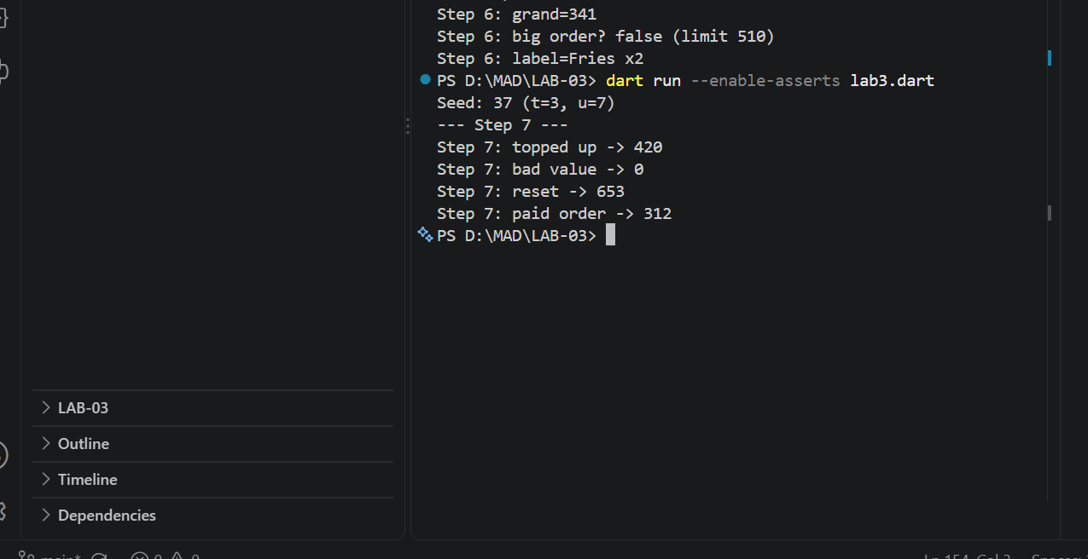

TASK 08:
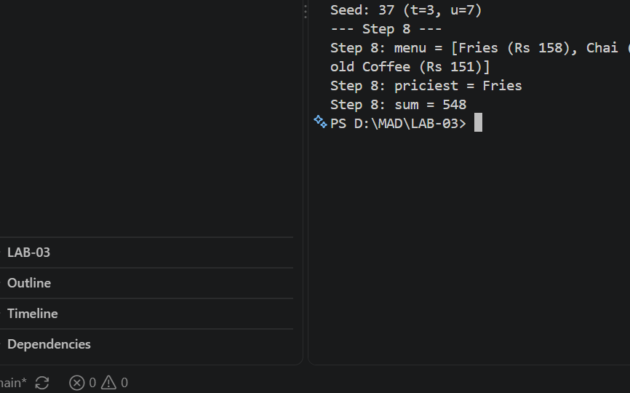

Task 09:
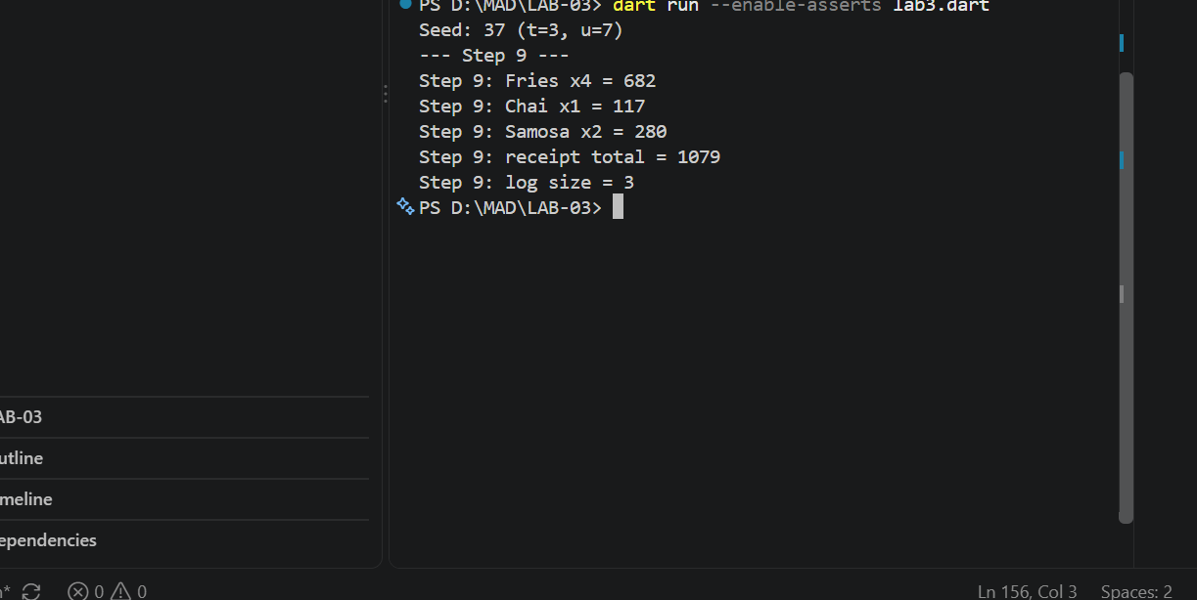

Task 10:
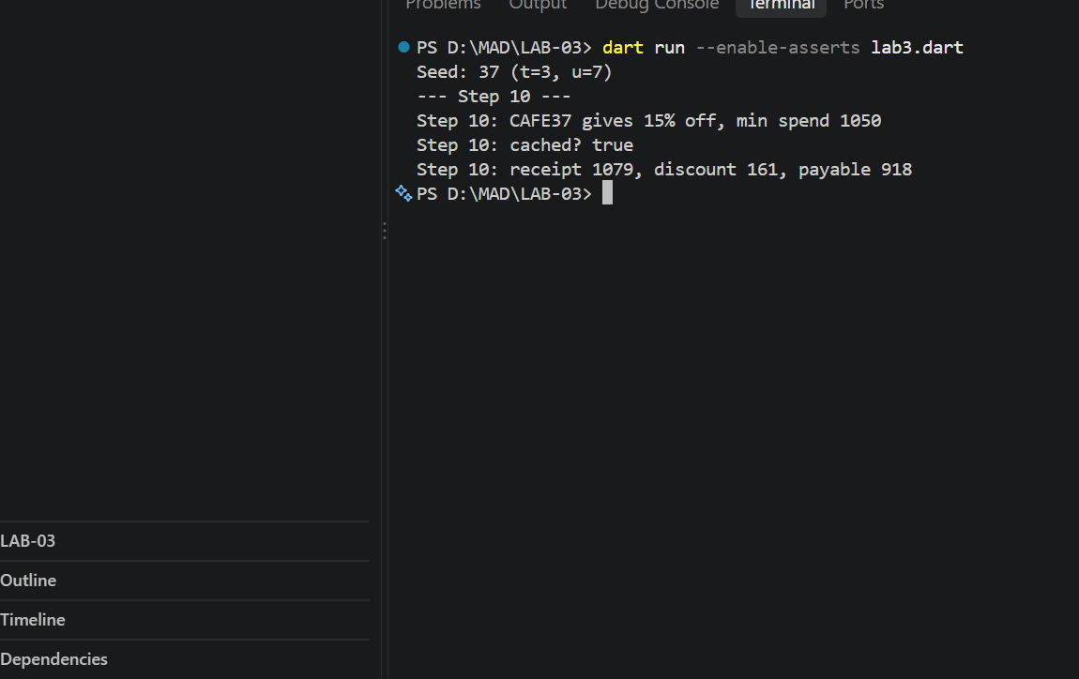

Relection Questions:
Q1. The shorthand saves writing the parameter names and the
this.x = x assignments by hand, so there is less code and fewer typos.
Q2. Use a named constructor to give a class another clear way to build a
NEW object (free(), fromString()). Use a factory when you may need to
return an existing/cached object (singleton, cache) instead of always
creating a new one.
Q3. In the constructor body the object already exists and the fields are
already set, so you can only change them (final fields cannot be
assigned). In the initializer list, the fields are set before the body
runs, so final fields can be computed there, but "this" cannot be read.
Q4. Getter: to expose computed data (like grand) without storing it twice,
so it can never get out of date. Setter: to validate or clamp a value
(like the balance) on assignment, which a public field cannot do.

